Project LunarX Status Report

Date: May 13, 2016

To: Tejasvi Kothapalli

From: Andrew Kou

Subject: Status Report 5/13

**Accomplishments**: This week, we have begun to code the program. Tejasvi has coded the rocket ship animation and the controls and how to zoom in the frame of the landscape when the rocket ship is about to land. Andrew has worked on the randomly generated landscape for which the rocket ship will land on and the other small graphic details, such as randomly generated stars and the flashing point values.

**Problems/Risks:** There are a couple bugs with our program. One of the biggest bugs is in landscape generation. In our landscape, there are flat platforms where the rocket will land on. However, about once in every ten runs, the program will generate a very odd landscape, such as the one displayed below.

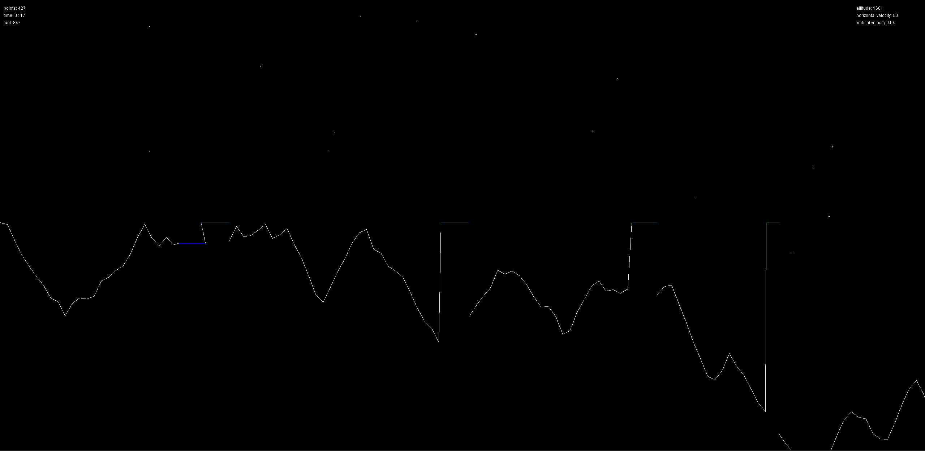

Another bug is the star generation. Some of the stars will appear partly in the window and partly out, and simply changing the incrementing the y-coordinate doesn’t seem to fix the problem. The last bug that showed up this week was that the rockets x and y value did not match with the actual coordinates in the code dude to the scaling. This however was fixed by creating a multiplier to scale the image down rather than using the Graphics2D scale() method.

**Next Steps:** This next week, we plan to finish the functionality of the game and begin to change small things to polish up our game, such as making a better looking rocket ship instead of the generic one that we currently have. Andrew will create a start menu for the game and also add an explosion animation for the rocket. Tejasvi will finish off the landing of the rocket when it makes contact with the landscape. After that, we will move into testing. We will split up testing responsibilities between the two of us when the time comes.